Lab 3.2 — Multi-Turn NLQ: Managing Data State and Chat History in BI

Table of Contents
Table of Contents 2
Introduction 3
Learning Objectives 3
Prerequisites 3
Step 1 — Create the Sales Table 4
Part 2 — Architecting the Conversational BI Explorer 6
Step 1 — Create the Streamlit App 6
Step 2 — Implement the Advanced State Logic 6
Part 3 — Testing the Multi-Turn BI Context 9
Step 1 — The First Interaction 9
Step 2 — The Contextual Follow-Up 11
Step 3 — The Iterative Pivot 12
Knowledge Check 14
Troubleshooting 14
Symptom: The AI responds with sql SELECT * FROM... and causes a SQL execution error. 14
Symptom: "Session state 'messages' not defined." 14
Conclusion 15

Introduction
In modern AI-BI architectures, "talking to a dashboard" requires more than just a single-shot Natural Language to SQL (NL2SQL) translation. Real-world business analysis is iterative. An executive might ask, "Show me total sales," followed by, "Now break that down by product," and finally, "Exclude the free tier."
To support this, your application must possess contextual memory. It must remember not just the user's current question, but the entire chain of previous questions and the current state of the dataset.
In this advanced lab, you will build a Conversational Data Explorer. You will utilize Streamlit's st.session_state to track multi-turn chat history. You will inject this history into Snowflake Cortex to dynamically iterate on SQL queries, effectively allowing the user to filter, group, and slice a live data table using continuous, conversational natural language.

Learning Objectives
Upon completing this lab, you will be able to:
- Manage persistent UI state in Streamlit to hold both chat history and active dataset queries.
- Architect a multi-turn NLQ prompt that provides Snowflake Cortex with schema context and conversational memory.
- Dynamically execute AI-generated SQL and render the resulting state as an interactive BI component.
- Handle exceptions and fallback states when an LLM generates invalid analytical queries.

Prerequisites
Before starting, ensure you have:
- Snowflake Enterprise Account with Cortex and Streamlit in Snowflake (SiS) enabled.
- SYSADMIN or equivalent privileges.
- Completion of previous Streamlit workspace navigation exercises.
Part 1 — Provisioning the BI Dataset
We need a structured dataset to query. We will create a simplified B2B sales pipeline table.

Step 1 — Create the Sales Table
Open a Snowsight SQL worksheet and execute the following to create the environment and sample data.
CREATE DATABASE IF NOT EXISTS ai_bi_workshop;
CREATE SCHEMA IF NOT EXISTS ai_bi_workshop.sales;

USE DATABASE ai_bi_workshop;
USE SCHEMA sales;

CREATE OR REPLACE TABLE pipeline (
opportunity_id VARCHAR,
company_name VARCHAR,
industry VARCHAR,
stage VARCHAR,
close_date DATE,
expected_revenue NUMBER
);

INSERT INTO pipeline VALUES
('OPP-1', 'TechFlow', 'Software', 'Closed Won', '2026-01-15', 150000),
('OPP-2', 'MediCorp', 'Healthcare', 'Negotiation', '2026-06-30', 250000),
('OPP-3', 'RetailMax', 'Retail', 'Prospecting', '2026-08-10', 50000),
('OPP-4', 'DataSys', 'Software', 'Closed Won', '2026-03-22', 120000),
('OPP-5', 'AgriGrow', 'Agriculture', 'Closed Lost', '2026-02-14', 85000),
('OPP-6', 'FinSecure', 'Finance', 'Negotiation', '2026-07-01', 500000);

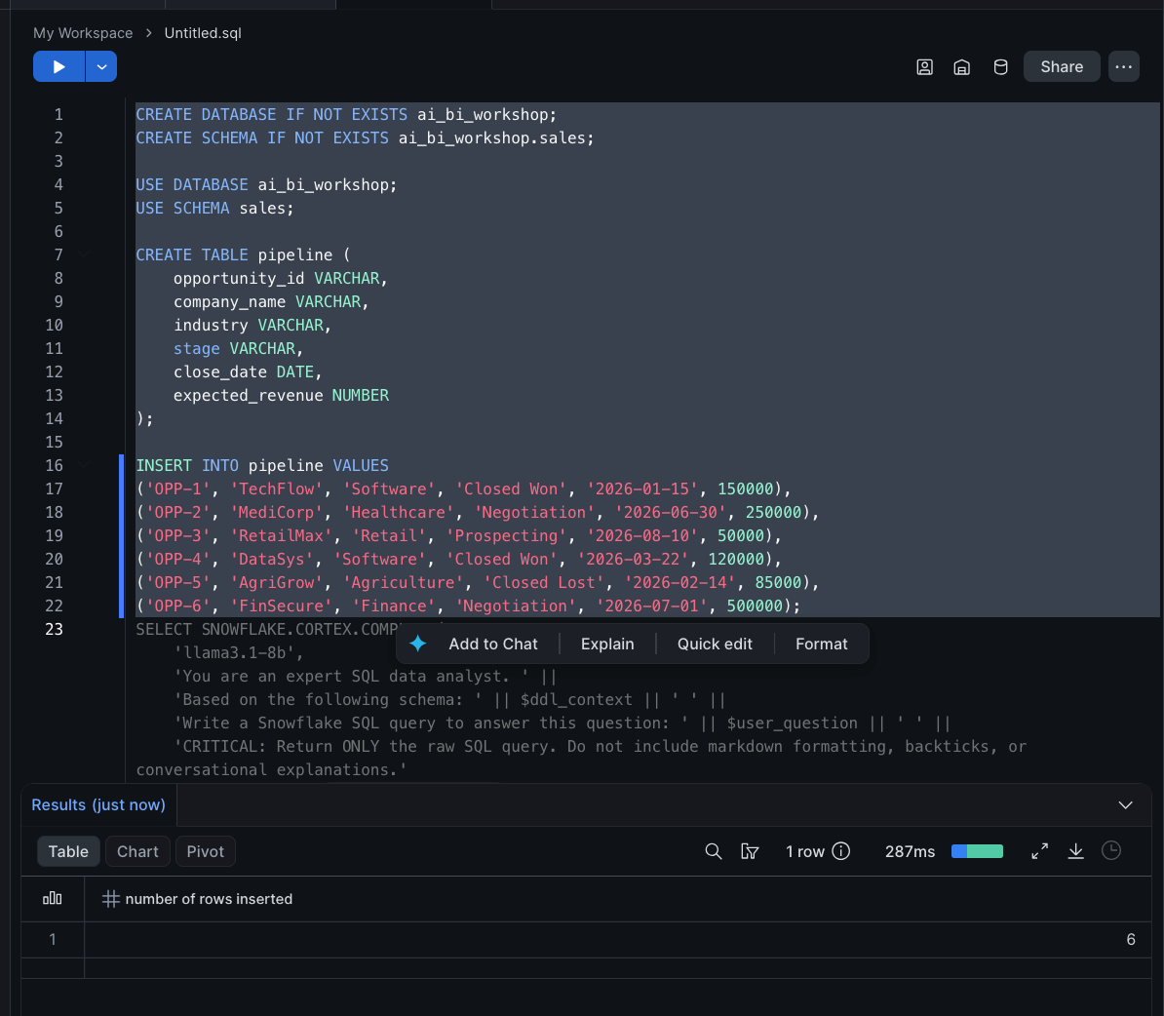

Part 2 — Architecting the Conversational BI Explorer
Now, we will build the advanced front-end.

Step 1 — Create the Streamlit App
- In the Snowflake Snowsight UI, navigate to Workspaces > My Workspace.
- Click the + Add new button and select Streamlit App.
- Name the app Conversational_Data_Explorer and press Enter.

Step 2 — Implement the Advanced State Logic
Delete the boilerplate code in the left-hand editor and paste the following Python script. Pay close attention to how st.session_state is used to store the messages (chat history) and the current_sql (the state of the dashboard).
import streamlit as st
from snowflake.snowpark.context import get_active_session
import pandas as pd

st.set_page_config(layout="wide", page_title="Conversational Data Explorer")
session = get_active_session()

st.title("🗣️ Conversational Data Explorer")
st.markdown("Iteratively filter and group the sales pipeline using natural language.")

# ==========================================
# 1. SESSION STATE INITIALIZATION
# ==========================================
# We must store BOTH the conversational history AND the active data state
if "messages" not in st.session_state:
st.session_state.messages = []

if "current_sql" not in st.session_state:
# The default state of the dashboard
st.session_state.current_sql = "SELECT * FROM ai_bi_workshop.sales.pipeline"

# ==========================================
# 2. RENDER THE BI DASHBOARD STATE
# ==========================================
# This section continuously reflects the current state of the data
st.subheader("📊 Live Data View")
st.code(st.session_state.current_sql, language="sql")

try:
# Execute the SQL stored in the session state
df = session.sql(st.session_state.current_sql).to_pandas()
st.dataframe(df,width="stretch", hide_index=True)

# Dynamic metric: Show total rows based on current state
st.metric(label="Total Rows in View", value=len(df))
except Exception as e:
st.error(f"Failed to execute query. The AI may have generated invalid SQL. Error: {e}")

st.divider()

# ==========================================
# 3. CONVERSATIONAL INTERFACE & HISTORY
# ==========================================
st.subheader("💬 Ask a follow-up question")

# Render previous chat history so the user can see their iteration path
for msg in st.session_state.messages:
with st.chat_message(msg["role"]):
st.markdown(msg["content"])

# Capture new user input
if prompt := st.chat_input("E.g., 'Group by industry' or 'Only show Closed Won'"):

# 1. Save user prompt to state
st.session_state.messages.append({"role": "user", "content": prompt})
with st.chat_message("user"):
st.markdown(prompt)

# 2. Construct the Multi-Turn Prompt Context
# We pass the schema, the CURRENT SQL state, and the entire chat history
history_string = "\n".join([f"{m['role'].upper()}: {m['content']}" for m in st.session_state.messages])

system_prompt = f"""
You are an expert SQL Data Analyst. Your job is to update the SQL query based on the user's latest request.

Table Schema: ai_bi_workshop.sales.pipeline (opportunity_id, company_name, industry, stage, close_date, expected_revenue)
Current Active Query: {st.session_state.current_sql}

Conversation History:
{history_string}

Instructions:
1. Look at the Conversation History to understand the user's latest goal.
2. Modify the Current Active Query to satisfy the new request.
3. Output ONLY the raw SQL query. Do not include markdown formatting (like ```sql).
4. Do not include any explanations. Just the SQL string.
"""

with st.chat_message("assistant"):
with st.spinner("Analyzing data request and rewriting SQL..."):

# 3. Call Snowflake Cortex
# We use string escaping for the prompt to avoid quote conflicts in the SQL string
escaped_prompt = system_prompt.replace("'", "''")
cortex_query = f"SELECT SNOWFLAKE.CORTEX.COMPLETE('llama3-70b', '{escaped_prompt}') AS ai_sql"

result = session.sql(cortex_query).collect()
new_sql = result[0]['AI_SQL'].strip()

# Clean up potential markdown formatting if the LLM disobeys instructions
if new_sql.startswith("```sql"):
new_sql = new_sql.replace("```sql", "").replace("```", "").strip()

# 4. Update the State
st.session_state.messages.append({"role": "assistant", "content": f"Updated query to reflect: {prompt}"})
st.session_state.current_sql = new_sql

# 5. Rerun the app to refresh the data view at the top of the script
st.rerun()

Part 3 — Testing the Multi-Turn BI Context
Now we will validate that the AI can remember previous filters and apply them cumulatively, mimicking a business user slicing data in a traditional BI tool.

Step 1 — The First Interaction
- Click Run to execute the application.
- Observe the default state: The current_sql shows SELECT * and the table shows all 6 rows.
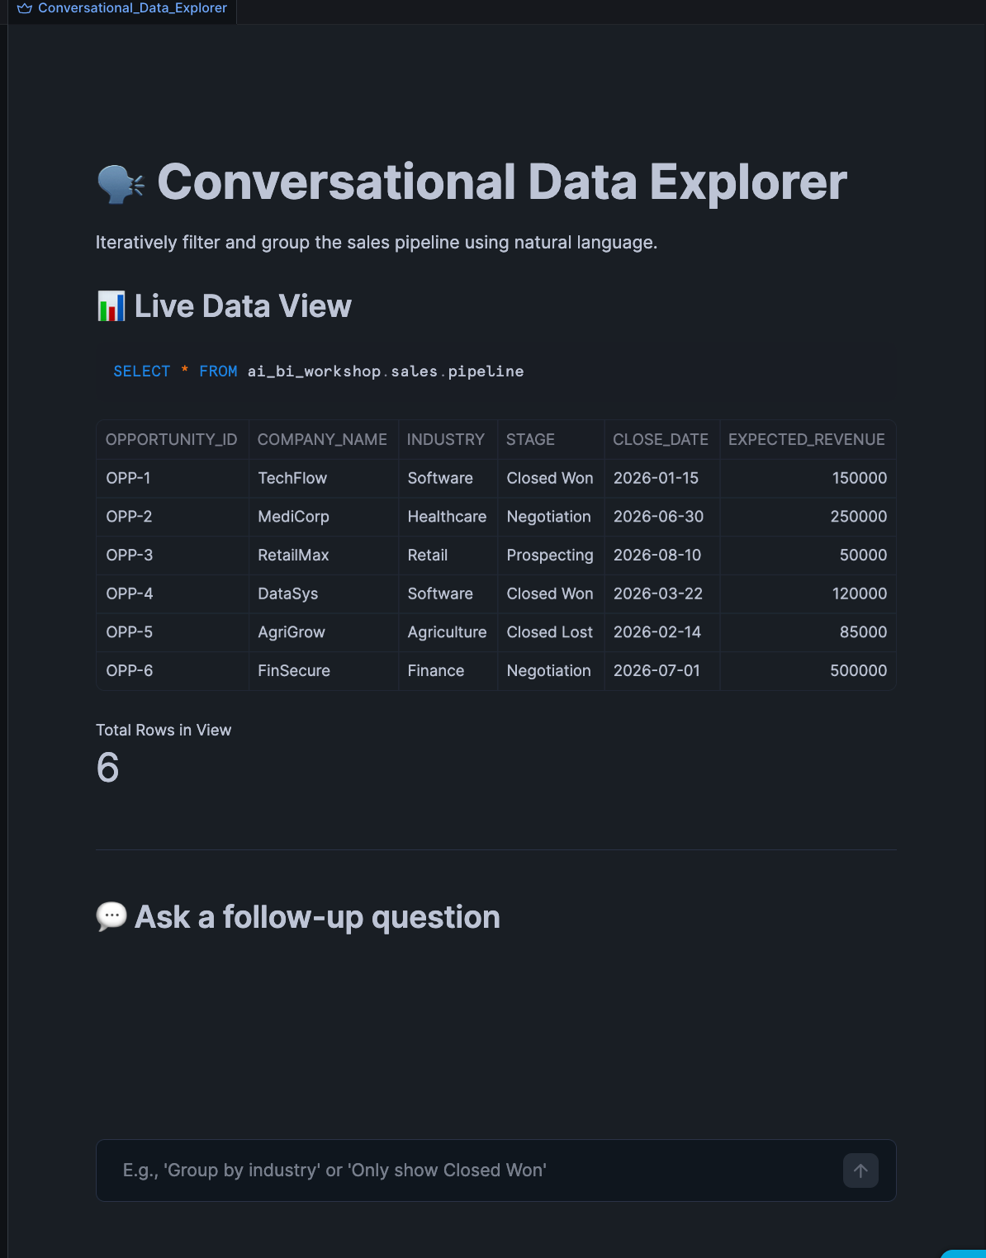
- In the chat box, type: Show me only the opportunities in the Software industry.
- Press Enter.
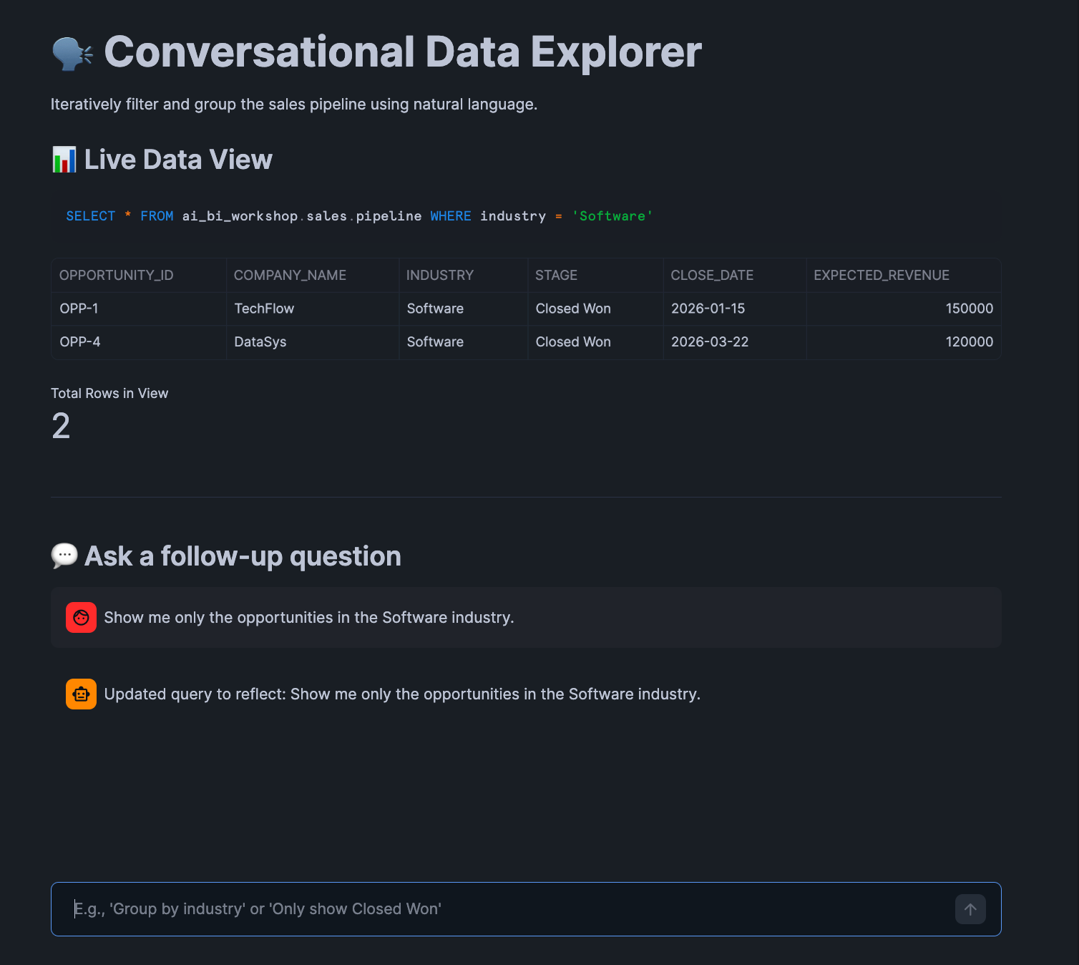
- Observe: The app will process, the SQL view will update to include WHERE industry = 'Software', and the dataframe will shrink to 2 rows.

Step 2 — The Contextual Follow-Up
- In the chat box, type: Now sort them by expected revenue from highest to lowest.
- Press Enter.
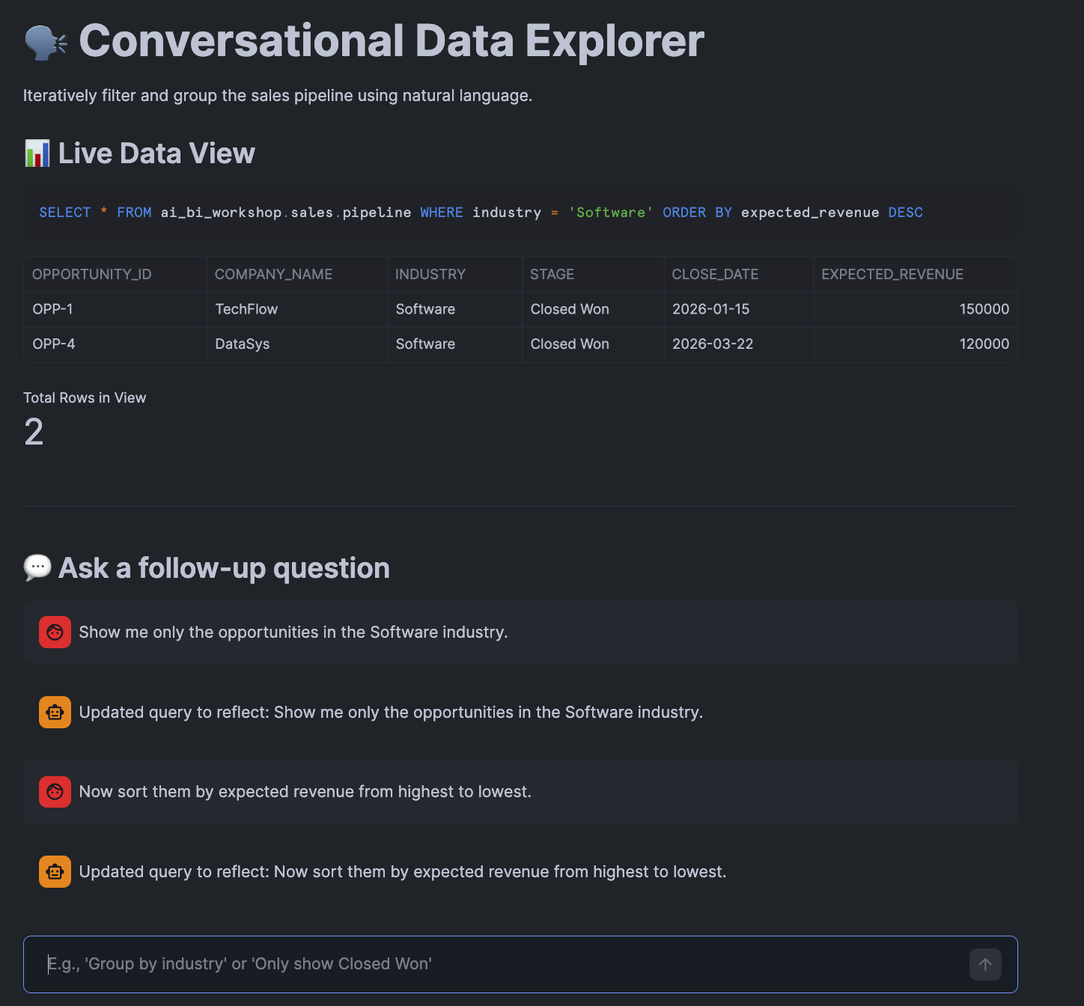
- Observe: The AI reads the st.session_state.messages and current_sql. It understands that "them" refers to the Software industry opportunities. The SQL updates to include ORDER BY expected_revenue DESC, keeping the previous WHERE clause intact.

Step 3 — The Iterative Pivot
- In the chat box, type: Actually, group it by industry and show me the total expected revenue for each.
- Press Enter.
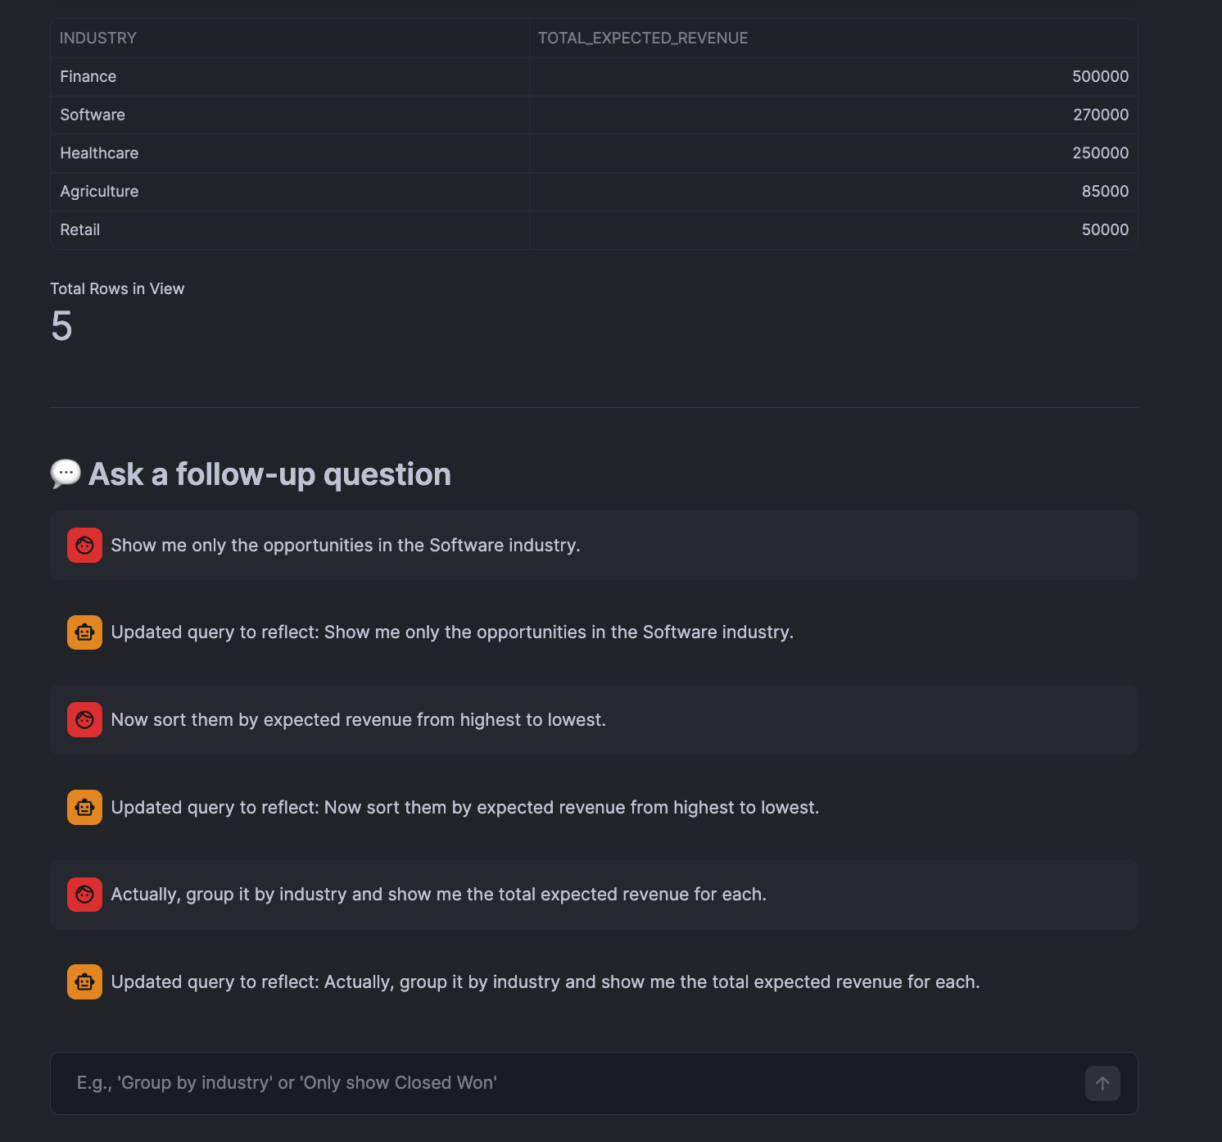
- Observe: The AI fundamentally rewrites the query into an aggregate (SELECT industry, SUM(expected_revenue) ... GROUP BY industry), removing the previous specific WHERE clause because the context of the user's prompt implies a higher-level grouping.

Knowledge Check
- Why do we pass st.session_state.current_sql into the LLM system prompt alongside the chat history?
  - Answer: The chat history tells the LLM the "intent" of the user over time, but the current_sql provides the explicit mathematical/syntactical state of the dashboard right now. It is much easier for an LLM to reliably modify a working SQL string than to build it from scratch based entirely on long conversational context.
- What is the purpose of st.rerun() at the end of the script?
  - Answer: Streamlit scripts execute top-to-bottom. When the user submits a chat, the script reaches the bottom, updates the state variables, and stops. st.rerun() forces Streamlit to immediately execute the script from the top again, ensuring the Live Data View component renders the newly generated SQL and dataframe.

Troubleshooting

Symptom: The AI responds with sql SELECT * FROM... and causes a SQL execution error.
Solution: Even with strict instructions, LLMs sometimes return markdown code blocks. The Python script includes a cleanup step (if new_sql.startswith("```sql"):), but if an LLM returns unexpected text alongside the SQL, it will break session.sql(). To fix this robustly in production, developers use LLM parsing libraries (like LangChain output parsers) or prompt engineering to force JSON structure.

Symptom: "Session state 'messages' not defined."
Solution: Ensure the state initialization block (Part 1 of the script) is at the very top of your Streamlit code, immediately after importing libraries and before any UI elements attempt to read from st.session_state.

Conclusion
In this lab, you built an advanced, stateful application that perfectly encapsulates the future of BI. By bridging Streamlit's session state with Snowflake Cortex, you created a UI where the business user's natural language acts as the dynamic filter, grouper, and slicer. Managing chat history in a BI context is not just about dialogue—it is about accurately translating human iteration into continuous data manipulation.

